Knowledge Rating Chart

Directions: Determine your understanding of each word in the chart below by putting
a ✔ in the appropriate column.

 | 1 | 2 | 3 | 4
word | I’ve never seen this word before. | I’ve seen this word before, but I don’t know what it means. | I know what this word means, but I’m not sure how to use it. | I know what this word means, and I can use it in a sentence.

Low-Level Example
 | 1 | 2 | 3 | 4
word |  |  | 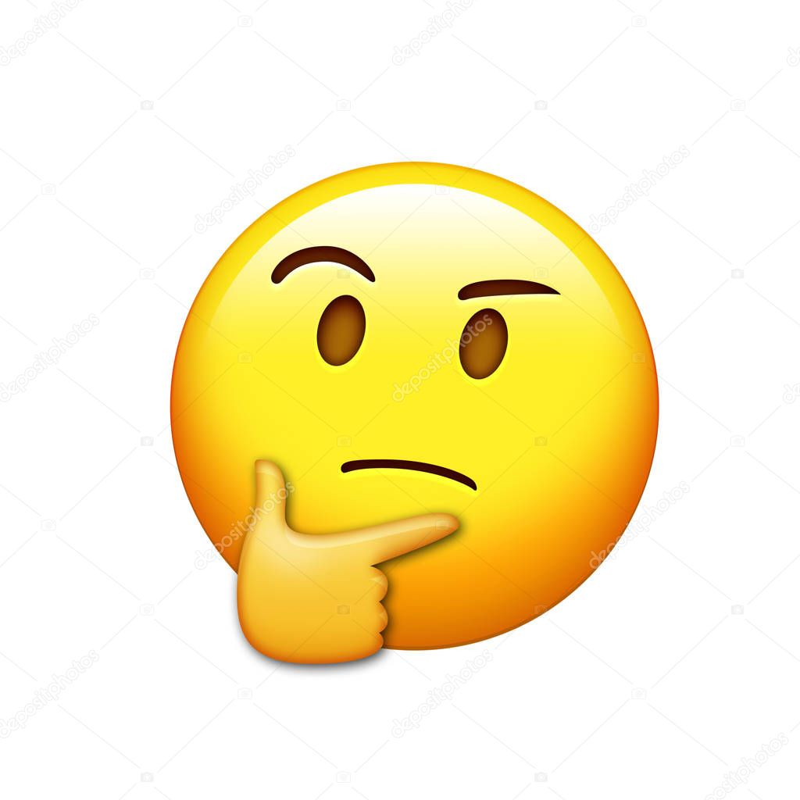 | 

